Comp 1123 midterm

February 11, 2015

**NAME:**

**STUDENT ID:**

* Open book. Any text, notes, and printouts are allowed.
* No electronic devices.
* Comments are not required.
* Each question has equal value.

|  |  |
| --- | --- |
| **Question** | **Grade** |
| **1** |  |
| **2** |  |
| **3** |  |
| **Total/30** |  |

# question 1

Write a class called Dog. The class has exactly 2 instance variables and 1 constant. The instance variables are used to store a dog’s name and age. Use a String for name and an int for age. The constructor has 2 parameters which are used to initialize the instance variables. Include getter and setter methods for the instance variables. Include a method called personYears which returns the dog’s age in person years (seven times the dog’s age). Also include a toString method which returns a one line description of the dog. In the toString method, use personYears to compute the equivalent human age. A sample driver class and output is shown below. If we were to run the Kennel class with your Dog class, it should produce the exact same output shown below. 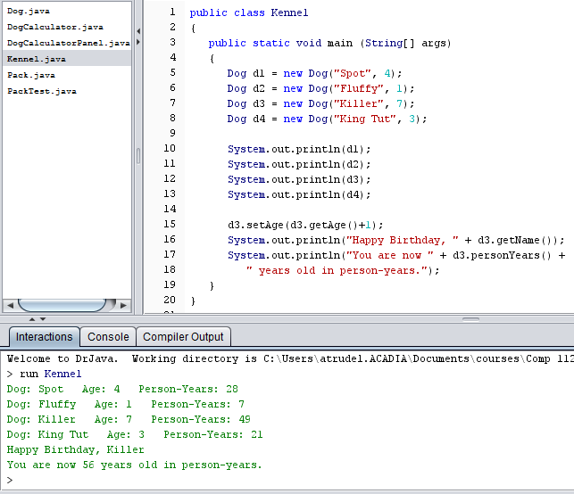

# question 1 continued

# question 1 continued

# Question 2

Write a class called Pack which has exactly two instance variables of type Dog. There is also a constructor and toString method. There are no other methods. Below, the output from a test class called PackTest is shown. If we were to run the PackTest class with your Pack class, it should produce the exact same output shown below.

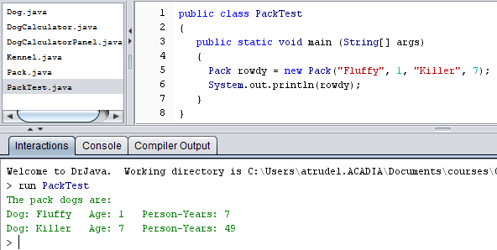

# question 2 continued

# question 3

Implement a calculator for converting dog years to human years. The following code displays a GUI.

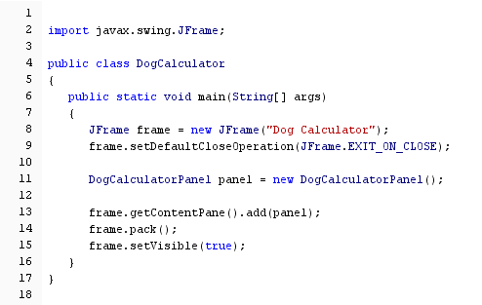

# question 3 continued

The initial GUI shown is:

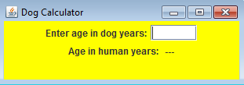

If the user types in 5 then the Enter key, the GUI changes to:

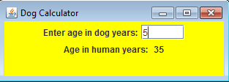

The DogCalculatorPanel class is shown on the next **TWO** pages. Please insert the missing code. You can assume the user will input a valid dog age. Only create one Dog object called fido. Use fido to do the age conversion calculation.

# question 3 continued

import java.awt.*;

import java.awt.event.*;

import javax.swing.*;

public class DogCalculatorPanel extends JPanel

{

private JLabel inputLabel, outputLabel, resultLabel;

private JTextField dogYears;

private Dog fido;

public DogCalculatorPanel()

{

# question 3 continued

add(inputLabel);

add(dogYears);

add(outputLabel);

add(resultLabel);

setPreferredSize(new Dimension(300, 75));

setBackground(Color.yellow);

}

private class TempListener implements ActionListener

{

public void actionPerformed(ActionEvent event)

{

}

}

}